E-COMMERCE SALES ANALYSIS PROJECT

1. Project Overview:
This project focuses on analyzing e-commerce sales data to identify business performance, customer purchasing behavior, profitable regions, and top-performing products.
The project was completed using:
- Excel for data cleaning and dashboard creation
- SQL (BigQuery) for data analysis queries
- Tableau for interactive dashboard visualization
- GitHub for project documentation and portfolio presentation

2. Project Objective:
The main objective of this project is to:
- Analyze sales and profit performance
- Identify high-performing product categories
- Understand regional profitability
- Track monthly sales trends
- Find top-selling products
- Generate business insights for decision-making

3. Dataset Information:
Dataset Used:
Sample Superstore Dataset

Dataset Features:
The dataset contains:
- Order Date
- Sales
- Profit
- Category
- Sub-Category
- Region
- Segment
- Product Name
- Quantity
- Discount
- Customer Information

4. Tools & Technologies Used:
Tool & Purpose:
Excel - Data Cleaning & Dashboard
SQL (BigQuery) - Data Querying & Analysis
Tableau - Interactive Dashboard
GitHub - Project Hosting

5. Data Cleaning Process (Excel):
The following data cleaning steps were performed:
Step 1: Checked Missing Values
- Verified null or blank cells
- Ensured dataset consistency
Step 2: Removed Duplicate Records
- Used Excel’s Remove Duplicates feature
Step 3: Standardized Date Format
- Converted order dates into a consistent format
Step 4: Created New Columns
Additional columns created:
- Year
- Month
- Profit Margin

Step 5: Verified Data Types
- Numeric columns formatted correctly
- Date columns converted into proper date format

6. Excel Dashboard Components:
The dashboard contains the following visualizations:
Visualization & Purpose:
KPI Cards - Display total sales, profit, orders, average order value
Monthly Sales Trend - Analyze sales growth over time
Sales by Category - Compare category performance
Profit by Region - Identify profitable regions
Segment Distribution - Understand customer segments
Top 10 Products - Highlight best-selling products

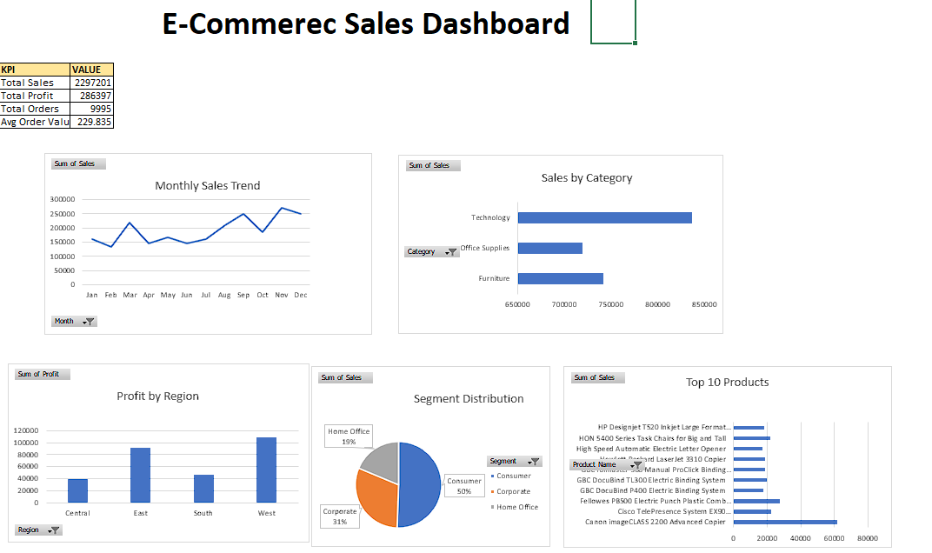

7. SQL Analysis Performed:
SQL queries were used to analyze:
- Total Sales
- Total Profit
- Monthly Sales Trend
- Category-wise Sales
- Region-wise Profit
- Top Products
- Average Order Value

Example SQL Functions Used
- SUM ()
- AVG ()
- COUNT ()
- GROUP BY
- ORDER BY
- ROUND ()

8. Tableau Dashboard:
An interactive dashboard was created in Tableau to visualize:
- Sales trends
- Product performance
- Regional analysis
- Customer segment contribution

Dashboard features:
- Interactive charts
- KPI indicators
- Professional layout
- Business-focused visualization

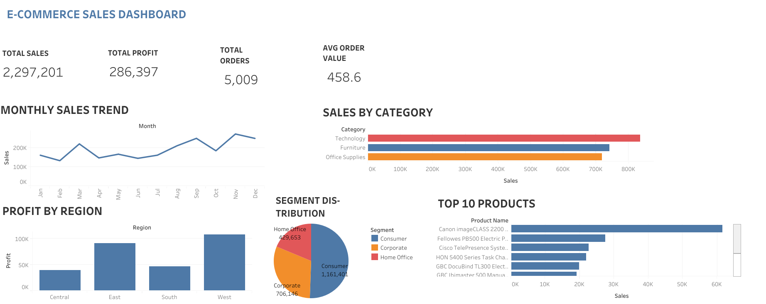

9. Key Insights:
- Technology category generated the highest sales.
- West region produced the highest profit.
- Consumer segment contributed the largest share of sales.
- Sales showed an upward trend during the later months of the year.
- A few products contributed significantly to total revenue.

10. Business Recommendations:
- Focus marketing efforts on high-performing categories.
- Increase inventory for top-selling products.
- Improve strategies in low-performing regions.
- Target consumer segment with loyalty programs.
- Analyze underperforming categories for optimization.

11. Project Outcome:
This project helped in:
- Understanding business performance through data
- Developing dashboard creation skills
- Practicing SQL analysis
- Learning business storytelling with data visualization

12. Files Included in Repository:
- Excel Dashboard File
- SQL Analysis File
- Tableau Dashboard File/PDF
- Dashboard Screenshot
- README.md
- Documentation File

13. Conclusion:
The E-Commerce Sales Analysis project demonstrates practical skills in:
- Data cleaning
- Data analysis
- SQL querying
- Dashboard development
- Business insight generation

